PROJECT OVERVIEW

This capstone project presents a customized Salesforce CRM solution for HandsMen Threads aimed at improving the way customer, product, and order data are managed across the organization. The system provides a structured and centralized data model that ensures important business information—such as customer records, product details, inventory statuses, and transaction histories—is accurate, accessible, and consistently maintained. To address key business needs, the CRM integrates automated processes such as order confirmation emails, loyalty program updates, low-stock alerts, and scheduled bulk order synchronization. These features help streamline operations, prevent manual errors, maintain healthy inventory levels, and enhance customer engagement. Through the use of Salesforce tools like Lightning App Builder, Flows, Apex, and data validation controls, the project delivers a scalable, efficient, and user-friendly CRM solution that supports both daily operations and long-term business growth.

OBJECTIVES

The primary goal of developing this CRM is to create a structured, automated, and reliable system that enhances both customer management and internal operations at HandsMen Threads. By focusing on accurate data capture, seamless process automation, and user-specific access control, the project aims to improve customer interactions, simplify order handling, and ensure efficient inventory tracking. These objectives directly support business value by enabling faster services, more personalized customer engagement, reduced manual work, and improved visibility across departments. Furthermore, the CRM equips the organization with a foundation that supports scalability, operational consistency, and long-term process improvement.

SPECIFIC OBJECTIVES

- Develop a centralized Salesforce data model to organize and store key business information efficiently.
- Maintain high data accuracy by applying validation rules and data quality controls within the user interface.
- Automate customer communication, including order confirmation emails and loyalty program updates.
- Implement internal workflow automations, such as inventory level alerts and scheduled bulk order processing.
- Strengthen technical proficiency in Salesforce development tools, including Apex, Flows, and Lightning App Builder.
- Build a scalable and adaptable system capable of supporting future business requirements and enhancements.

TECHNOLOGY DESCRIPTION

This project uses several Salesforce platform features to build a customized and efficient system for managing business processes at HandsMen Threads. Each component plays a specific role in ensuring data accuracy, secure access, and workflow automation.

Salesforce Platform
Serves as the primary environment for building custom applications, storing business data, and automating processes.

Custom Objects
Custom objects are created to store business-specific records such as orders, products, customer profiles, and loyalty details.

Tabs
Tabs provide direct access to custom objects, enabling users to view, create, and manage records easily.

Custom App
A tailored application is developed to group essential tabs, dashboards, and utilities for users, offering a focused workspace aligned with business needs.

Profiles
Profiles control user permissions by defining what data and features each user can access within the system.

Roles
Roles organize users in a hierarchy that supports data visibility and reporting based on an individual’s position in the company.

Permission Sets
Permission sets grant additional access rights without changing a user’s profile, giving flexibility in managing permissions.

Validation Rules
Validation rules ensure that all required information is accurate and complete before a record is saved, supporting strong data quality.

Email Templates
Predefined email templates help standardize communication for order confirmations, loyalty updates, and stock alerts.

Email Alerts
Email alerts work with automation tools to send templated emails automatically when certain conditions are met.

Flows
Flows automate processes such as updating loyalty status, generating notifications, and performing record updates without manual intervention.

Apex
Apex is used for advanced business logic and automation that cannot be achieved through standard configuration tools, including scheduled processing for bulk order updates.

DETAILED EXECUTION OF PROJECT PHASES

This section outlines the step-by-step phases followed in developing the Salesforce solution for HandsMen Threads, ensuring a structured and systematic implementation.

1. Developer Org Setup

- Created a Salesforce Developer Org to serve as the project environment.
- Configured company information, default settings, and security configurations.
- Installed necessary packages and enabled required features such as Dev Hub, Flows, and Email Deliverability.
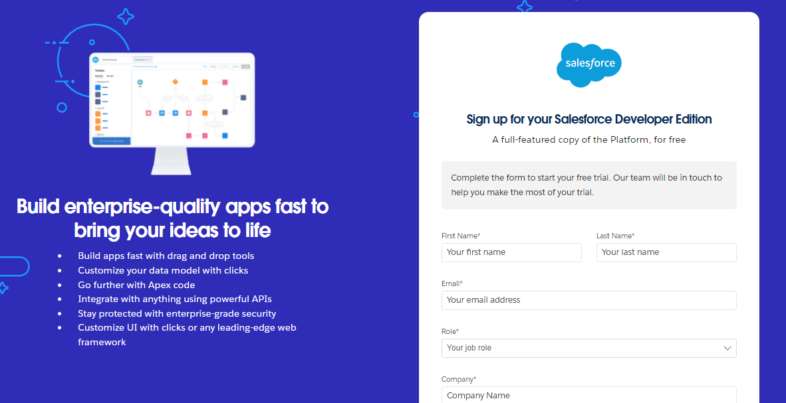

2. Custom Object Creation

- Designed data models based on the business workflow.
- Created custom objects such as HandsMen Customer,Handsmen Orders, Handsmen Order, Inventory, and Marketing Campaigns.
Step Followed:
- Navigate to Setup - Object Manager - Create - Custom Object
- Provided Label, Name, and Enable reports/ search
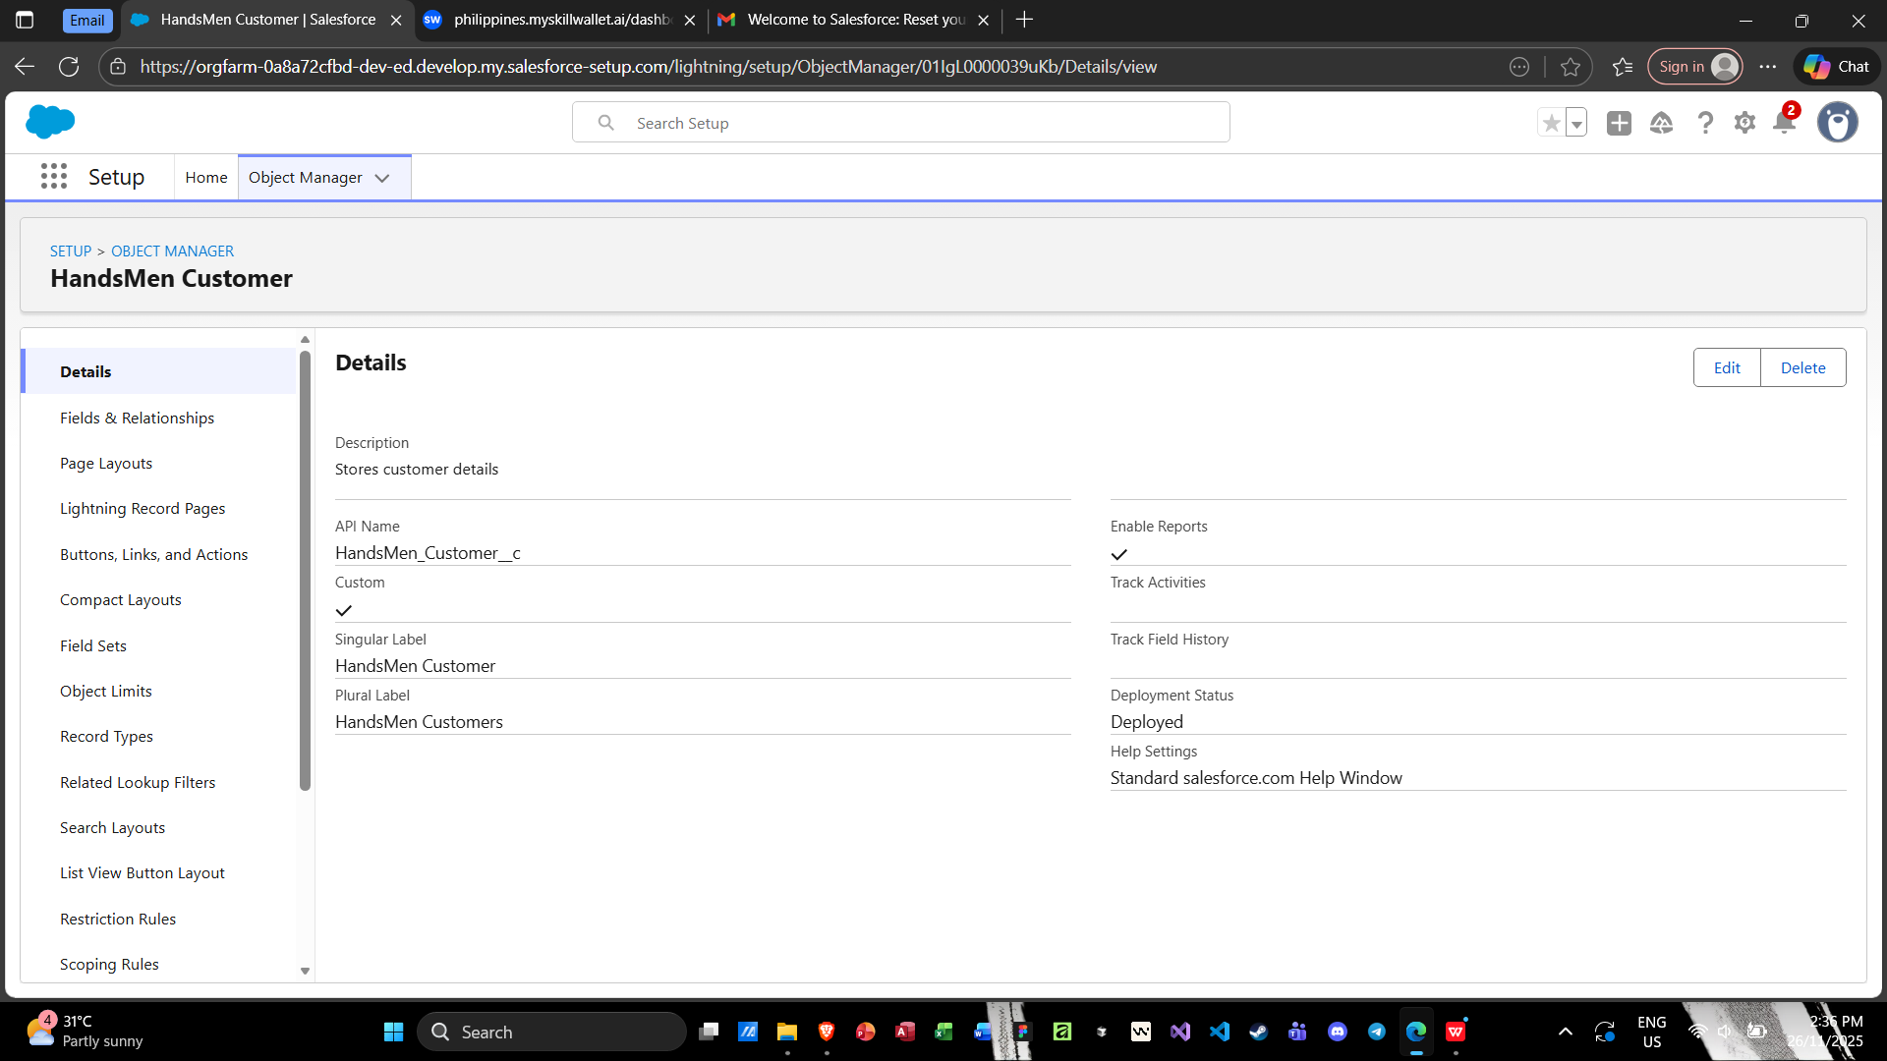
- Saved and Created Tabs for Each object

3. Lightning App Setup

- Developed a custom Lightning App named HandsMen Operations App.
- Added custom objects, reports, dashboards, and utility items to the navigation bar.
- Customized Lightning Record Pages using Lightning App Builder for better usability.

4. Validation Rules Implementation

- Created validation rules to prevent incorrect or incomplete data submission (e.g., quantity cannot be negative, product fields cannot be blank).
- Added error messages aligned with user workflows.
- Tested rules to ensure they accurately enforce data quality.

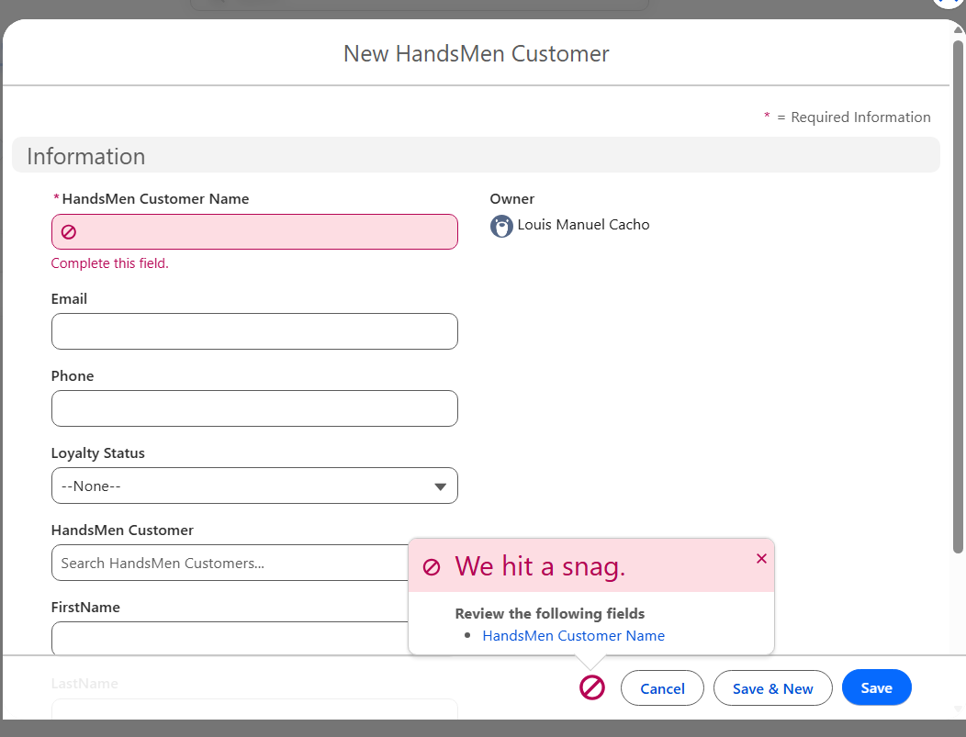

5. User Roles & Profiles Setup

- Designed a role hierarchy representing the business structure (Admin → Manager → Staff).
- Configured profiles such as System Administrator, Operations User, and Sales User.
- Set field-level security, object permissions, and tab visibility according to each profile.

6. User Creation

- Created test users to simulate business roles.
- Assigned appropriate profiles, roles, and permission sets.
- Tested login access and visibility controls to confirm correct configuration.
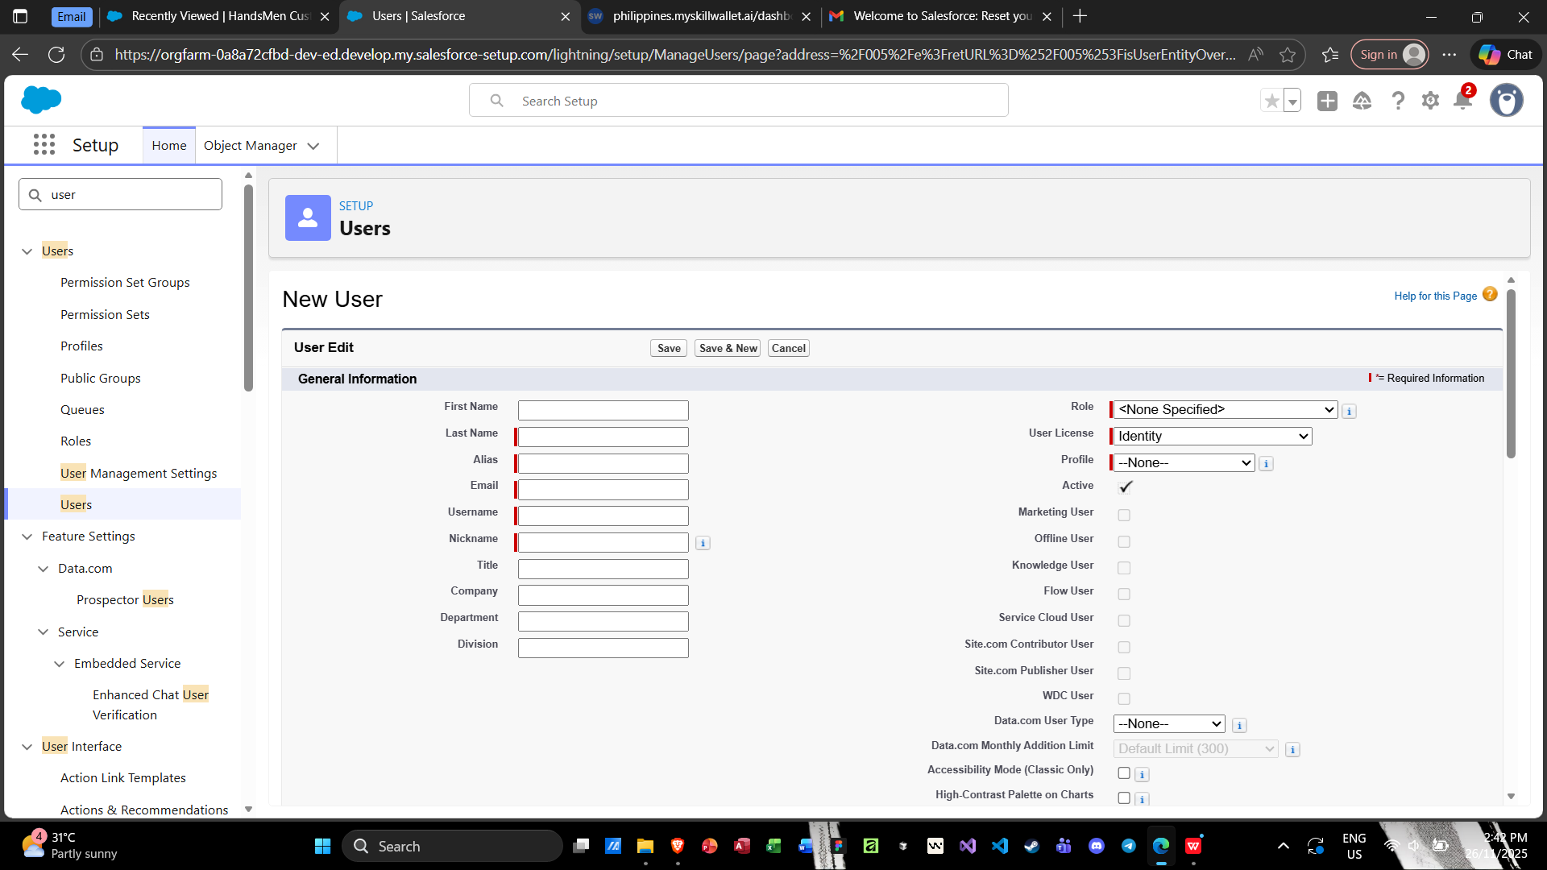
7. Email Templates & Email Alerts

Designed email templates for:

- Order Confirmation
- Loyalty Status Update
- Low Stock Notification
- Created email alerts that work with flows or triggers to send automatic notifications.
- Verified deliverability through test records.

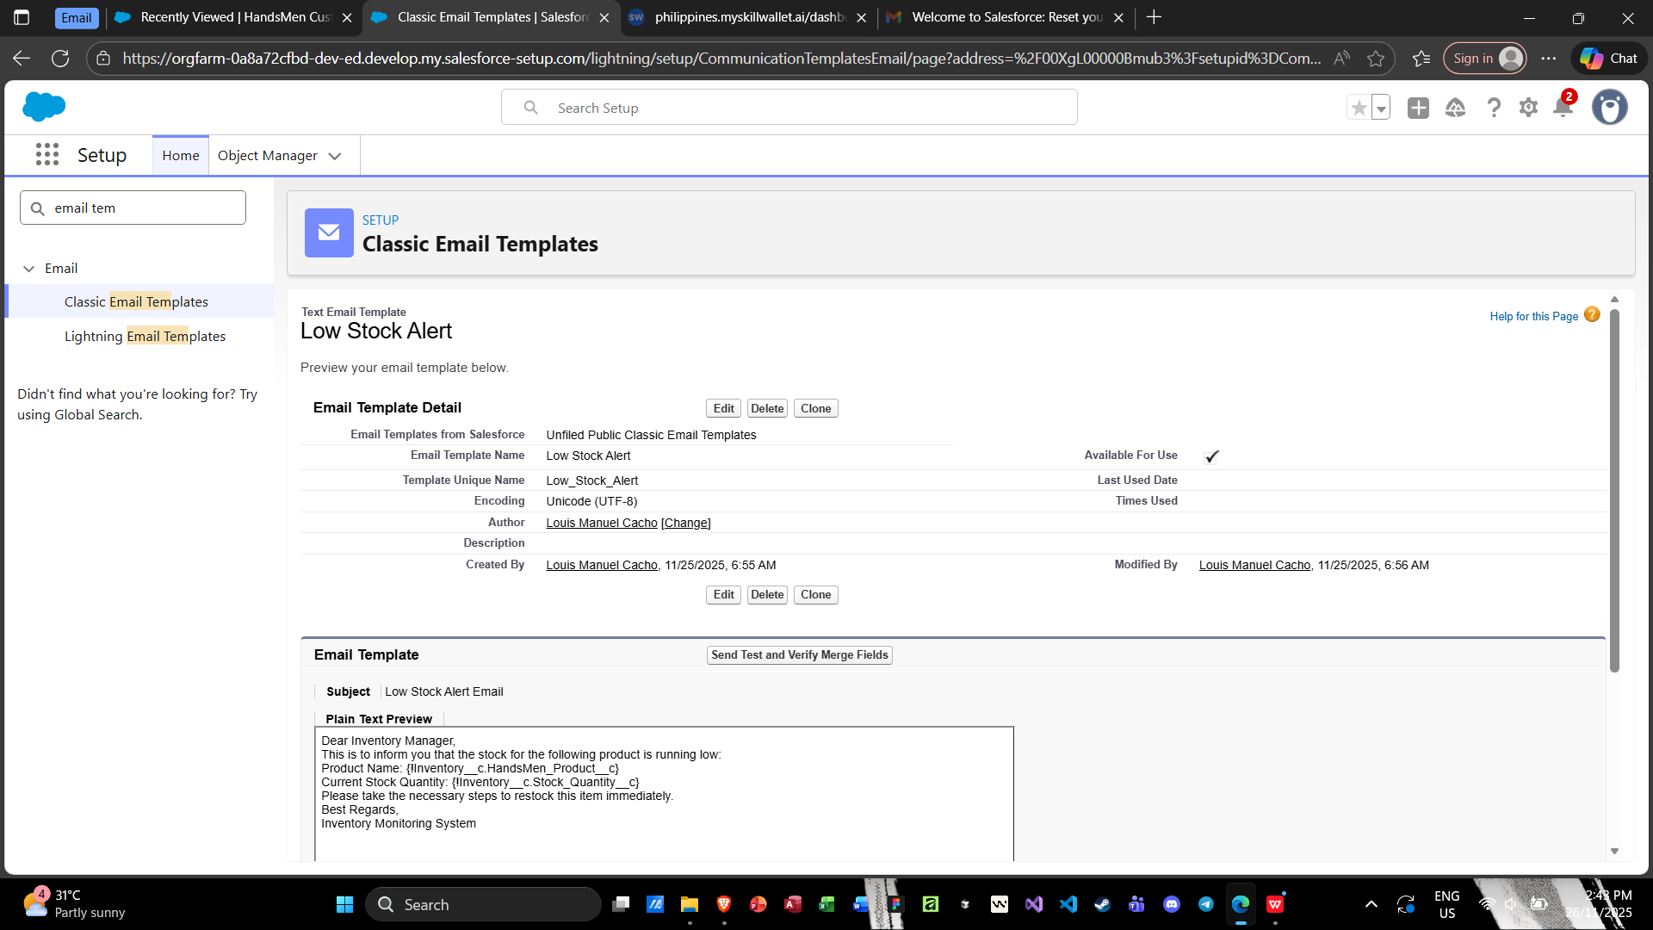
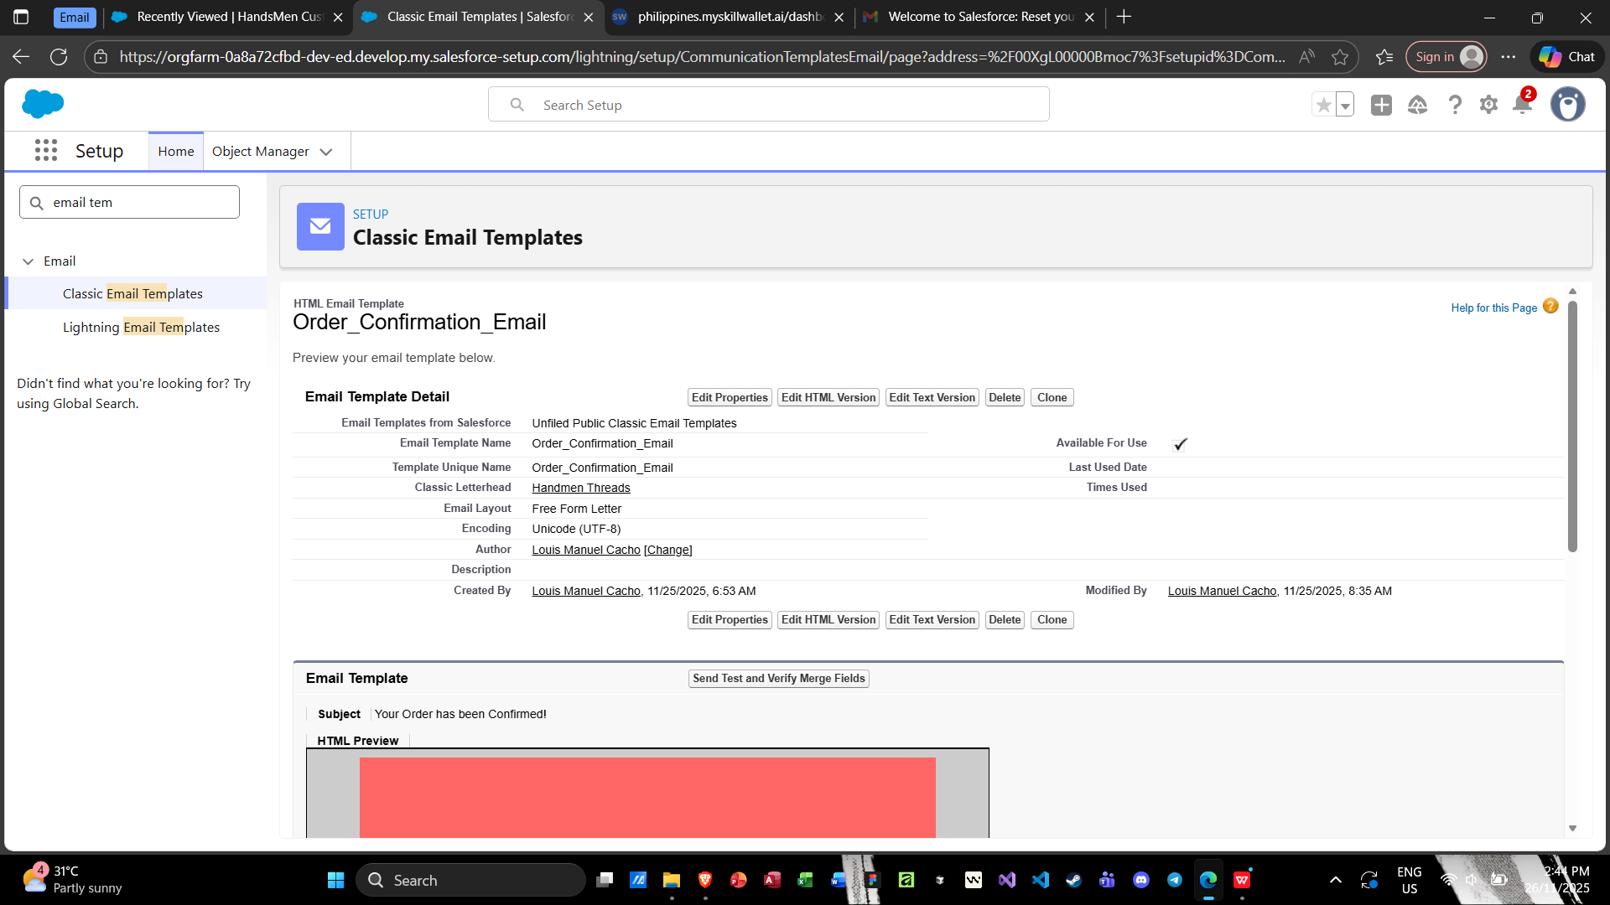
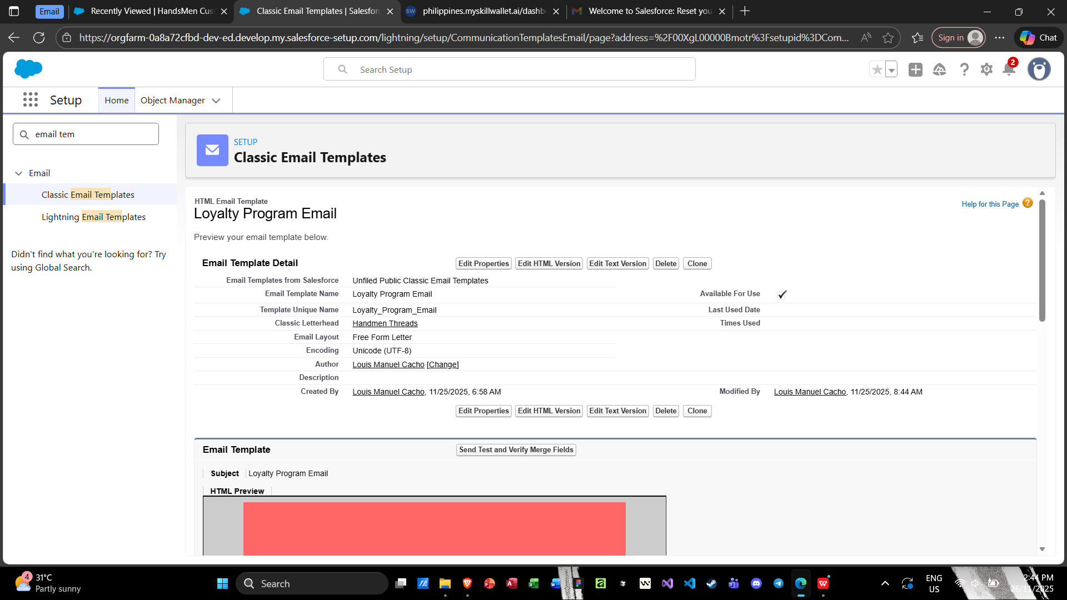
8. Flow Implementation

Built Record-Triggered Flows for:

- Updating loyalty levels based on order history
- Sending stock alerts when inventory drops below threshold
- Automating field updates during order confirmation
- Designed Scheduled Flows for daily processing of bulk orders.
- Ensured error handling with fault paths and debug logs.

- Order Confirmation Flow
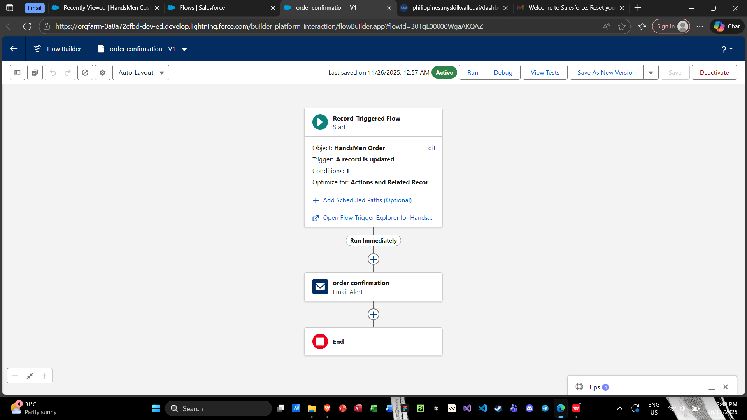
- Stock Alert Flow
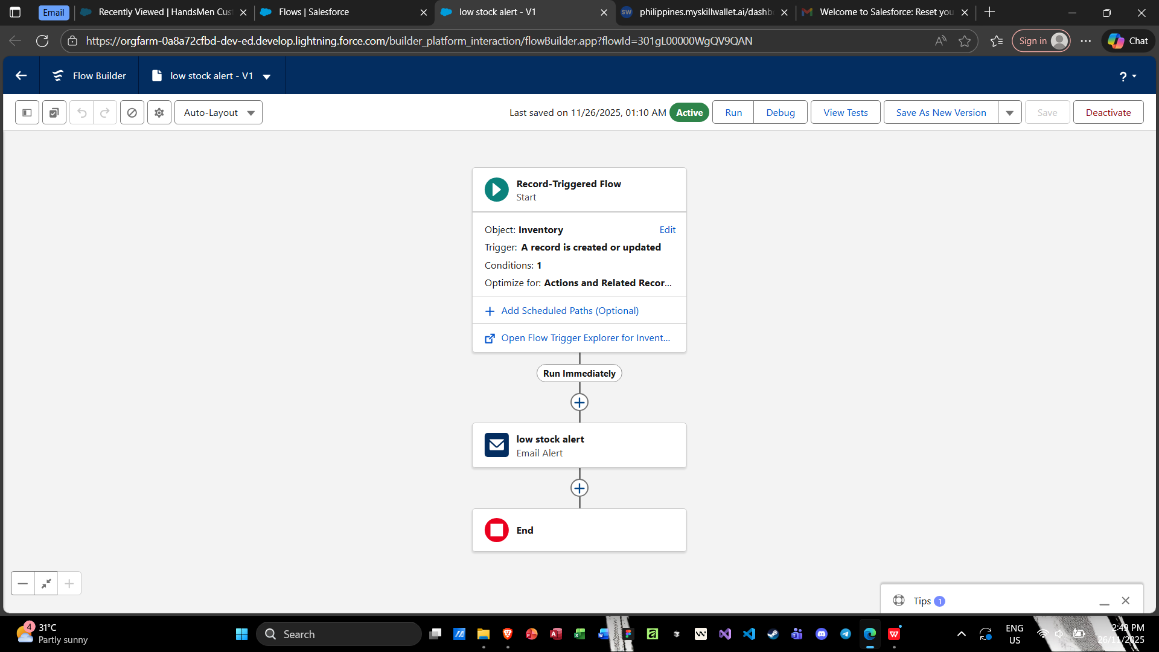
- Scheduled Flow: Loyalty Update
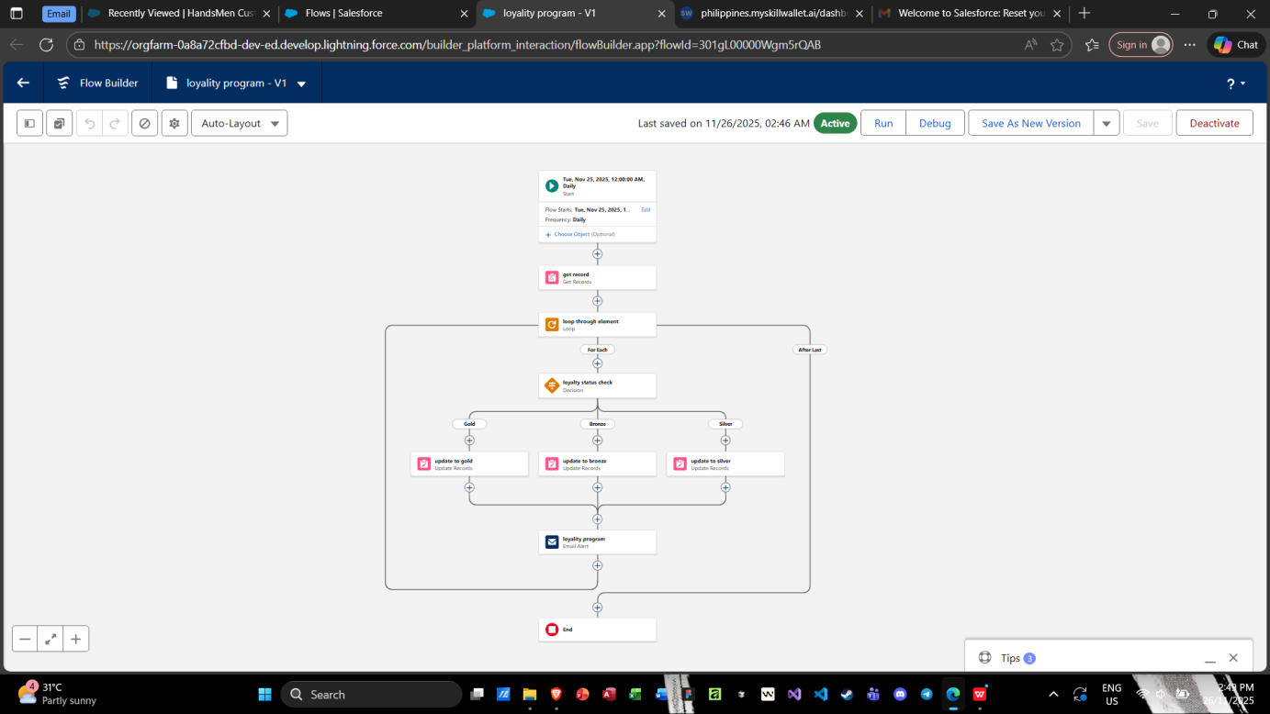

9. Apex Development

- Developed Apex triggers for advanced logic not achievable with flows, such as complex inventory deduction.
- Created asynchronous Apex classes for scheduled daily financial and inventory updates.
- Implemented test classes to meet Salesforce deployment standards.

PROJECT EXPLANATION WITH REAL-WORLD EXAMPLE

A realistic walkthrough of customer interactions and system operations.

To better understand how the solution works, imagine a real scenario in HandsMen Threads’ daily operations.

1. Customer Registration

- A walk-in or online customer named Ava Santos wants to purchase clothing items.
- A sales representative enters her information into the Customer object:
- Name: Ava Santos
- Email: ava.santos@example.com
- Loyalty Status: New Customer

The system checks input through validation rules to ensure the email address is present for notifications.

2. Product Setup

- Warehouse staff enters new products:
- Product Name: Denim Jacket
- Stock: 12
- Price: 1,500 PHP
- Category: Outerwear
- Each product includes fields for stock and category, enabling later reporting and automation.

3. Order Placement

- Ava purchases 1 Denim Jacket.
- The Sales Representative creates an order:
- Customer: Ava Santos

- Product: Denim Jacket
- Quantity: 1
- Status: Pending → Updated to Confirmed
- When the order is confirmed:
- Stock automatically decreases from 12 → 11
- An email confirmation is sent to Ava
- The system logs the transaction in the Inventory Log

4. Inventory Update

After deducting the stock:
Inventory Log captures:
- Product: Denim Jacket
- Change: -1
- Date: Today
- Performed by: Sales Representative

If the stock falls below 5 units:
The Low Stock Flow triggers

Warehouse receives an email alert:
“Denim Jacket stock is now low (4 units remaining). Please restock soon.”

5. Loyalty Program Update

Each confirmed order adds loyalty points to Ava’s record.

Example:

- Ava earns 10 points for this purchase.
- Once she reaches a threshold (e.g., 50 points), the system updates her status to:
- “Silver Member”

A personalized loyalty update email is automatically sent.

6. Email Notifications

The system sends:

- Order Confirmation – triggers instantly when order is confirmed
- Loyalty Update – if Ava reaches a new tier
- Low Stock Alert – sent to warehouse team
- Daily Bulk Summary – sent at midnight to Finance and Warehouse

These automated alerts ensure smooth communication.

7. User and Role Authorization

Each user sees only what they need:
- Sales Representative sees Customers and Orders
- Warehouse User sees Products and Inventory Logs
- Finance User sees daily summaries
- Admin sees and manages everything
- This ensures secure and efficient access.

SCREENSHOTS
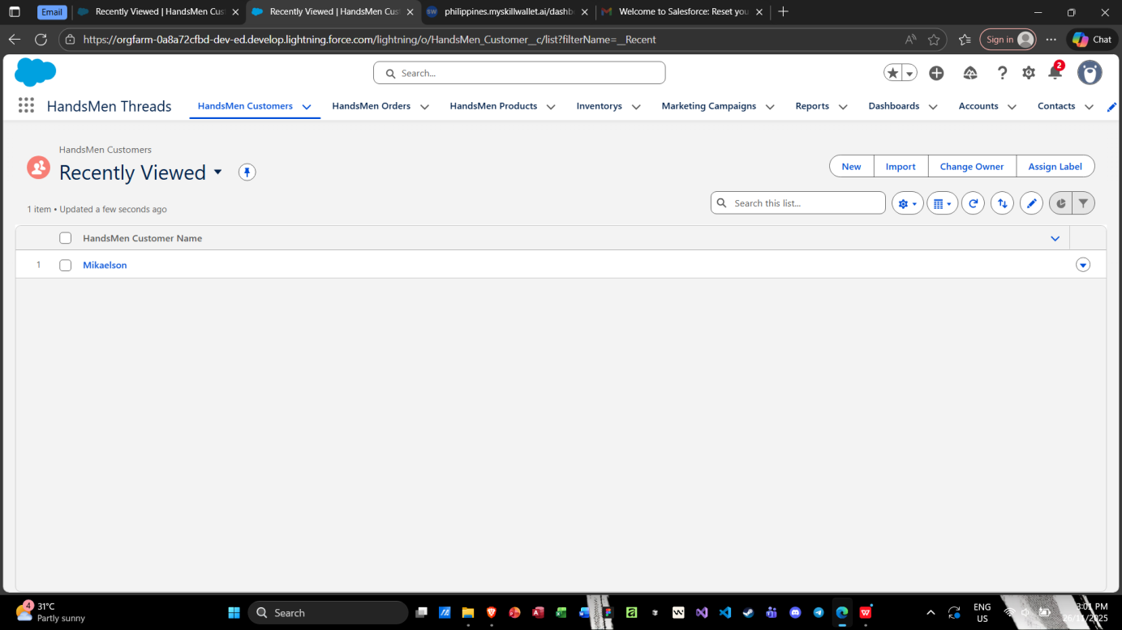
Fig: Custom App HandsMen Threads

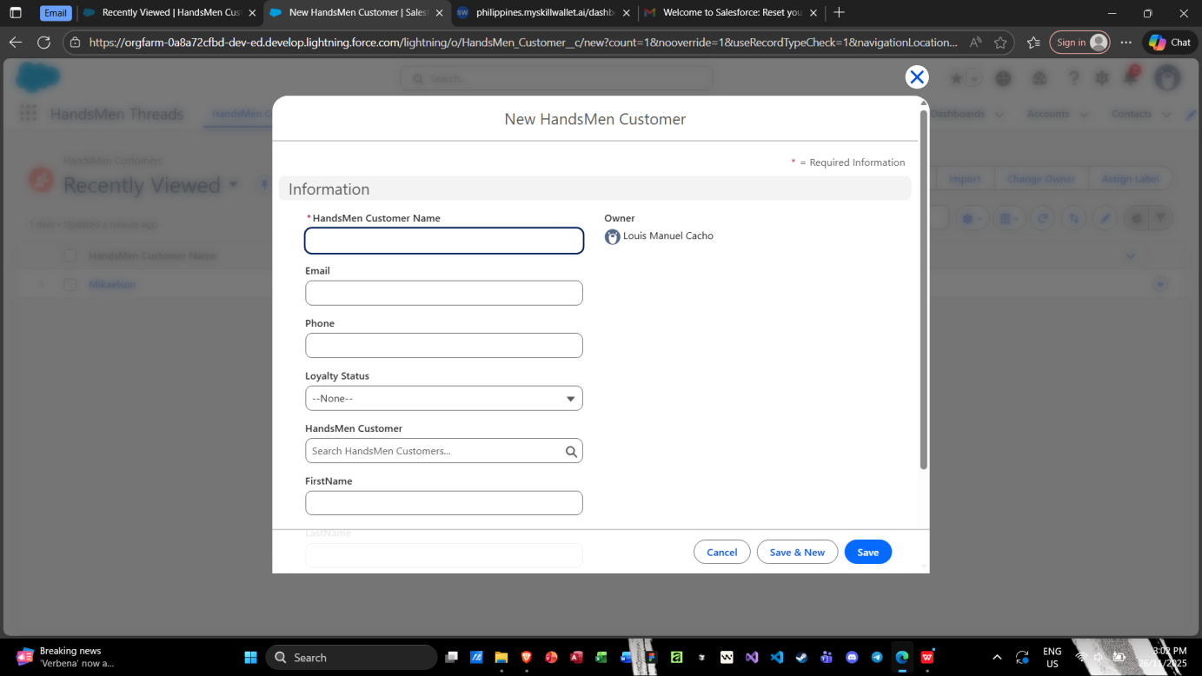
Fig: Customer Creation in HandsMen Threads
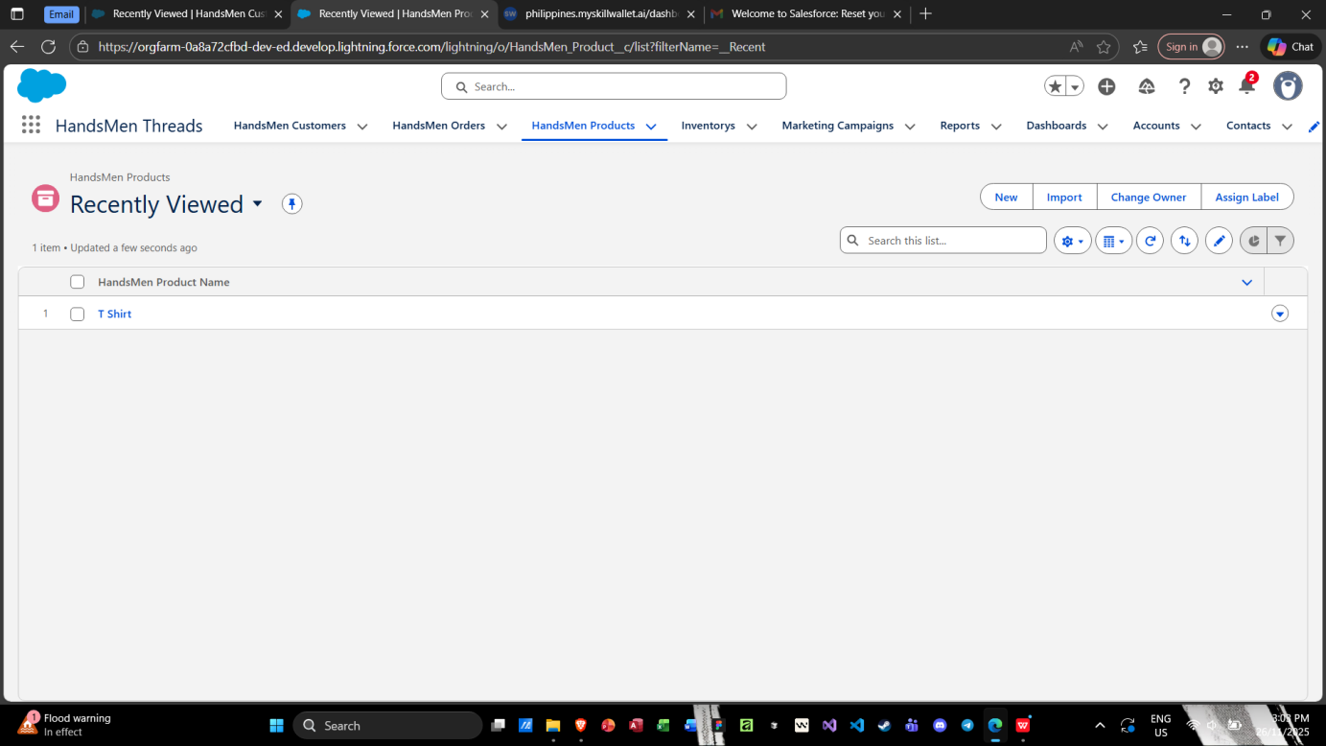
Fig: HandsMen Threads Products

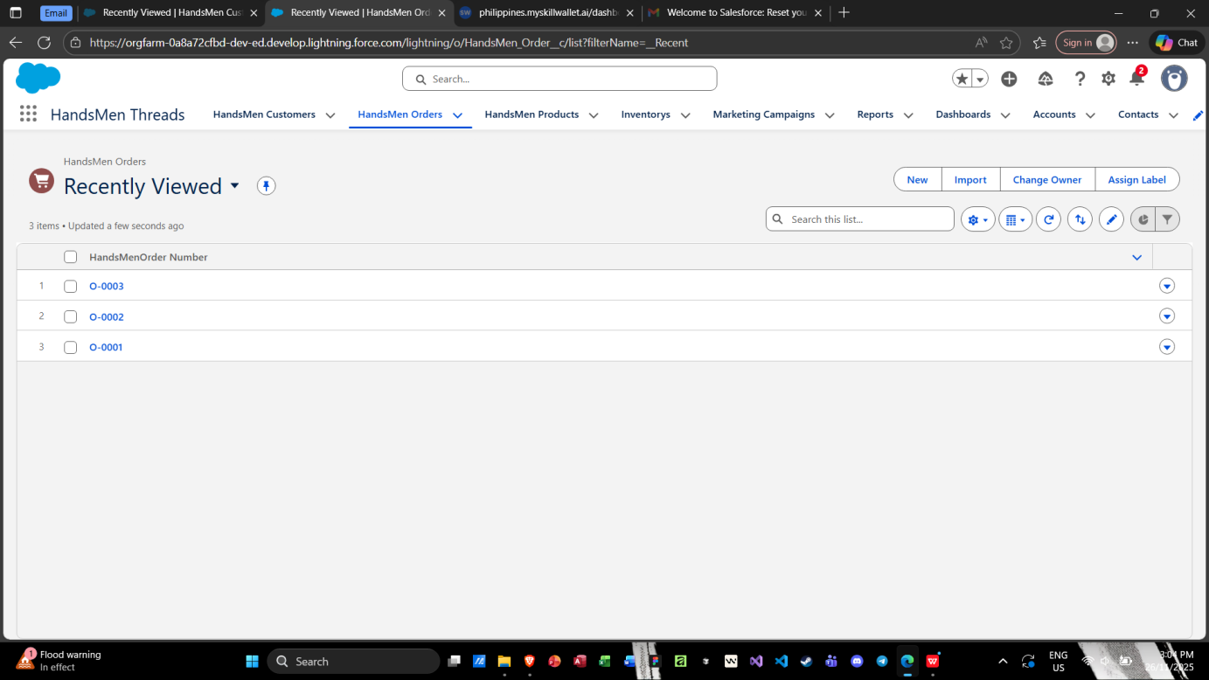
Fig: HandsMen Threads Orders

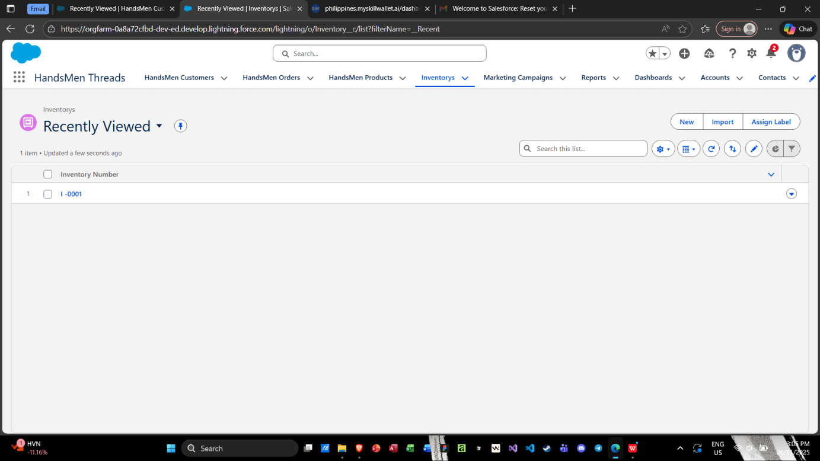
Fig: HandsMen Threads Inventories

CONCLUSION

This project successfully developed a structured and automated Salesforce system tailored to the needs of HandsMen Threads. By integrating custom objects, data validation, automation tools, and Apex logic, the system improves data accuracy, streamlines operations, and enhances customer engagement. The platform not only supports current business processes but also strengthens operational reliability and boosts overall efficiency. The implementation demonstrates the value of well-designed digital systems in supporting modern business workflows.

Future Scope:
While the current system addresses key operational needs, there are several opportunities for expansion:

- Mobile App Integration: Allow warehouse staff and sales agents to update records directly from a mobile device.

- AI-Powered Recommendations: Use Einstein AI to recommend products and predict inventory shortages.

- Advanced Reporting Dashboard: Provide visual analytics for sales trends, customer retention, and stock movement.

- Customer Self-Service Portal: Enable customers to track orders, update details, and view loyalty points online.

- Integration with Payment Gateways: Automate payment status updates and financial reconciliation.

- Multi-Warehouse Management: Support larger operations with multiple storage locations.

These advancements can further enhance efficiency, improve customer satisfaction, and support long-term digital growth.

